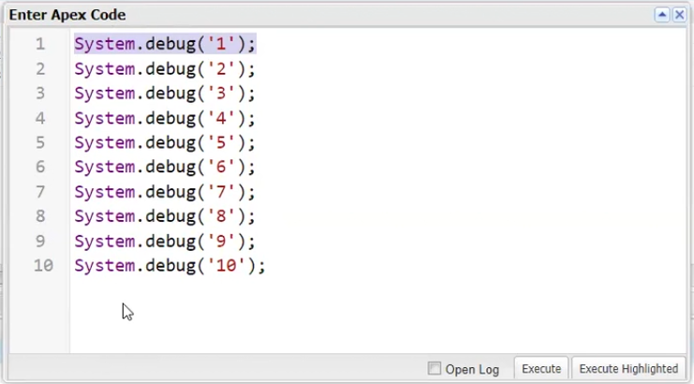

Here code is repeated this is called code redundancy

In the sales force the execution time is 10000 millisecond means

10 seconds

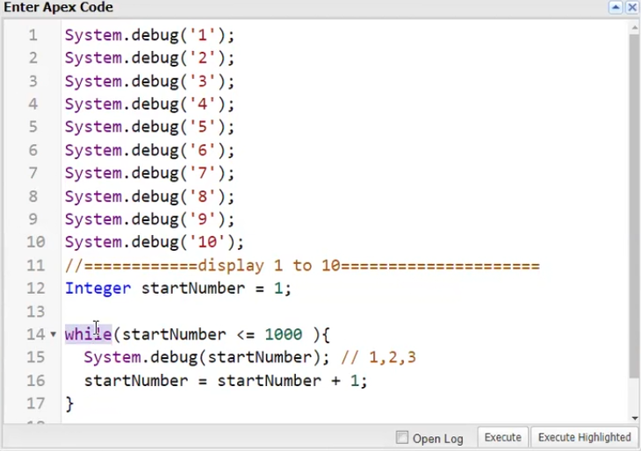

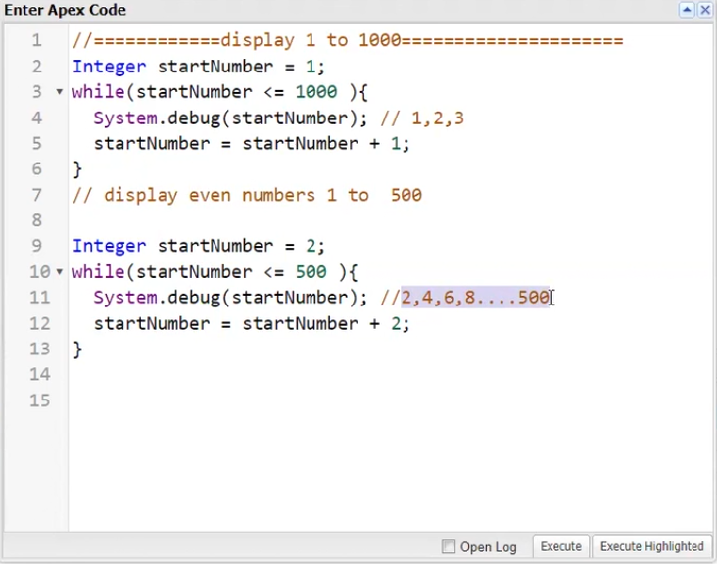

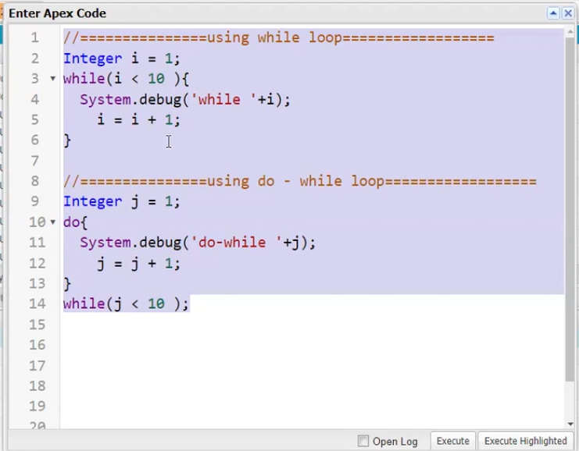

Loops are used to iterate the set of statements multiple times